

Environment Baselining Pilot (EBP) measurement protocols
The Environment Baselining Pilot aims to gather a range of data on GB farms to establish a baseline for assessing the carbon stocks, GHG emissions and other metrics related to environmental impact.
This report provides the methodology employed in year one of the pilot. Being a pilot project, this methodology will be critically reviewed and potentially additional metrics added as the project progresses.

Any enquiries regarding this publication should be sent to us at:
AHDB, Siskin Parkway East, Middlemarch Business Park, Coventry CV3 4PE
Email: info@ahdb.org.uk
September 2026

1. Aims and objectives of the EBP

1.1 Overview
When AHDB set out its plan for the Environment Baselining Pilot (EBP), a significant challenge for agriculture at the time was a lack of information on farming’s impact on the changing climate and the changing climate’s impact on farming businesses. Within that, a major gap in data was around carbon removals and sequestration. There was limited evidence on what carbon stocks agriculture held, where they were, whether they were going up or down and what practices increased or diminished them. Our desire was to improve the evidence in this area, collecting evidence that could help us to understand how the agricultural industry could be part of the solution, not just part of the problem.
Our secondary desire was to understand the other public goods that farmers may be delivering for the nation. Examples include biodiversity, water quality, flood mitigation, as well as managing carbon stocks. The plan was to use the measurements and data we would already be capturing to understand more about environmental sustainability.
Key in the design of the EBP was the ability to accurately measure change over time, and the behavioural change element of the project. Does the provision of good-quality measurement data to farmer decision-makers help deliver positive change on those farms? The inclusion of soil organic carbon measurement to 1 metre (or soil C horizon); aerial LiDAR survey at 16 points per square metre; and the use of an accredited farm carbon calculator gives an excellent baseline from which these farm businesses can be remeasured and compared against over time to determine whether positive change has actually taken place. We hope that the granularity of this measurement also allows us to seek academic partners to interrogate and publish peer-reviewed publications from the EBP; we see this as essential if more accurate calculations are to be approved and used in the future.

1.2 Aim
The EBP is designed to improve how UK agriculture’s carbon and environmental performance is measured and reported. It aims to generate the evidence needed to support more accurate UK-specific reporting and inform the design of any future national baselining scheme.
The pilot project aims to understand and explore:
- Whether more accurate data and knowledge can support better decisions on farm to improve their environmental position
- The range of on-farm GHG emissions and carbon removals and how they can be improved over time
- Soil carbon stocks, the link with soil health and soil’s capacity to remove and store carbon
- The environmental impact of agricultural practices
- The possibilities of new technology for measuring environmental change
Secondary aim
- If levy payers deliver other public goods – e.g. biodiversity, water management

1.3 Key elements of the EBP
- The EBP combines deep soil carbon sampling (to 1 m), high‑resolution LiDAR and a standardised carbon audit to produce robust, repeatable baselines across all land uses including woodland
- The EBP is looking at where we can use technology such as LiDAR to affordably baseline but also will explore remote sensing technologies such as earth observation and AI/machine learning in order to reduce the cost of future baselining
- As a pilot project, it is collecting data more deeply than any existing national or commercial schemes

2. Measurements
The pilot has used a combination of direct measurement and modelling on a range of different farms throughout Great Britain and includes non-farmed areas, such as woodland, in addition to productive land.
The following assessments were undertaken to create a baseline data set for each farm.
- LiDAR scan to:
  - Map above-ground woody biomass in trees and hedges
  - Estimate the below-ground woody biomass in the roots
  - Estimate the carbon stocks in the woody biomass both above and below ground
  - Create run-off risk maps for each farm, using the length and steepness of slopes, soil texture and long-term weather data to inform the map
- Soil testing to:
  - Measure the carbon stocks, down to 1 m or the C horizon on farmed and unfarmed land
  - Measure the soil nutrients and texture around those carbon cores
- A common carbon audit to:
  - Estimate their year one, year three and year five GHG emissions (Tier 2) and carbon removals (Tier 1)
- An action plan for each farm based on the results of the carbon audit
- An assessment of the drivers of behavioural change
- A survey to provide land management and farming practices information to complement the measurements taken

The activity undertaken to achieve the above will provide:
- Estimates of the carbon stored in the woody biomass both above and below ground
- Overall assessment/estimation of carbon stocks held on the farm, and where those stocks are
- Run-off risk maps, identifying areas of the farm where there is risk of soil or nutrient loss
- An estimate of the greenhouse gas emissions and carbon removals for the farm based on current farming practices
This data will provide a baseline of each of the farm’s environmental credentials and a starting point for tracking change over time. We are aiming to remeasure after five years of the original measurements, allowing change to be measured, reported and recognised.
These parameters were assessed on up to 300 ha of land on each farm participating in the pilot. Where a farm was smaller than 300 ha, then all of the farmland was included where parcel size (>1 ha), typography and access enabled sampling to take place.

2.1 Estimating above- and below-ground carbon stocks in woody biomass
Above- and below-ground carbon stocks in woody biomass include carbon stocks held in woody vegetation such as trees and hedges, including in their roots. This was assessed using LiDAR (Light Detection and Ranging) to provide a 3D image of the landscape from which the volume of the woody biomass could be estimated.

2.2 Aerial LiDAR scanning survey
The contractor for this work was Bluesky International Ltd.
- Acquisition took place when leaves were off the trees (November to March) in order to allow better penetration of the laser, through tree canopies, to the ground surface and to determine the different layers and volumes of branches. Imagery at this time of year also enabled better differentiation between deciduous and coniferous trees
- The LiDAR resolution was 25 cm (16 points per square metre) as this was judged by AHDB to represent the best compromise between a higher resolution which would capture enough detail to measure change over time, while not increasing the amount of data to be processed too much, thus optimising the cost of the survey and the processing of the data. This judgement was made based on feedback from those tendering for the work
- It was recognised that the models used to estimate the conversion of volumes of above-ground biomass to carbon stocks are currently limited by the scarcity of published work on destructive sampling. Hence, currently, more precise LiDAR data does not necessarily equate to more accurate estimates of above-ground carbon stocks. It is expected this will improve over time
- A minimum of three LiDAR laser returns was stipulated, to capture the vertical complexity of the environment, which is particularly important for woodland and hedges
- Ortho imagery (aerial photography) with a resolution of 12.5 cm, or better, was mainly captured at the same time as the LiDAR scanning, or as recently as possible

2.3 LiDAR interpretation
The contractor for this work was Trinity Agtech Ltd.
The point cloud and aerial photography were used to classify the vegetation as follows:
1. Woodland.
2. Hedgerows and scrub.
3. Escaped hedgerow and individual trees.
Various metrics were then calculated, such as vegetation height, canopy cover and biomass, which are required to estimate carbon stocks. Methods were developed considering the application of allometric equations designed for tree stands (including Forrester, D. et al., 2017) and area-based methods (including Yu, X., 2010).
For hedgerows, several sources for methods were drawn upon, including O’Sullivan et al., 2024 and Burrell et al., 2024.
Additionally, run-off risk was assessed by analysing topographical features derived from the Digital Terrain Model (DTM) and vegetation coverage from the LiDAR data allowing areas most at risk of run-off to be identified (RUSLE).
Below-ground biomass (BGB) was calculated using the above-ground biomass (AGB) estimates for each stand using root-shoot ratios. Using the percent of broadleaf and conifer within typical stands, ratios specific to each tree type were employed (IPCC, 2019). BGB for hedgerows and scrub were calculated using a specific BGB equation for each class and segmented area of scrub or hedgerow, using the AGB and type as input variables (Black et al., 2023)
The methodologies adopted in this study were selected to reflect current best practice for estimating vegetation structure and carbon stock from remotely sensed data. For woodland, the approach drew on established allometric and area-based methods widely used in forest carbon assessment, ensuring that estimates are grounded in peer-reviewed techniques applicable to tree stands. For hedgerows, methods were selected from recent literature because they are specifically developed for linear woody features and are therefore more appropriate than generic woodland equations. Likewise, the below-ground biomass calculations were based on recognised IPCC guidance for woodland and on more targeted equations for hedgerows and scrub, reflecting the differing growth forms and biomass allocation patterns of these vegetation classes.

2.4 Assessing soil carbon stocks

2.4.1 Sample collection
The contractor for this work was Agricarbon UK Ltd.
Fields were stratified by estimated carbon stock variability and random sampling points allocated within each stratum. Sampling intensity was based on a minimum detectable difference (MDD) of 5 tonnes of carbon per ha and was varied according to land use. The aim was to achieve between 1.25–1.65 cores per ha for farmland and woodland and approximately 0.5 cores per hectare for moorland.
Soil cores of 36mm diameter were extracted from sampling points, down to a depth of 100 cm or the C horizon, whichever came first. Sampling points were recorded by Global Positioning System (GPS). All deep soil cores were divided into the following horizons if the depth of the core allowed: 0–15, 15–30, 30–60, 60+ cm. This enabled a better understanding of where in the soil profile soil organic carbon (SOC) is being stored, the bulk density at different depths, and allows the impact of cropping and management practices to be tracked with subsequent sampling.
Where a manual sampler was used, the maximum depth of sampling was 60 cm. This equipment was used when access to the field or sampling site was difficult for the utility terrain vehicle, e.g. due to waterlogging or no suitable vehicle access and in some cases woodland and moorland. In total, 3.6% of all fields were sampled with the handheld corer either partially or wholly; these were predominantly in woodland and moorland land parcels.
Figure 1. Soil core taken to 100 cm depth where conditions allow
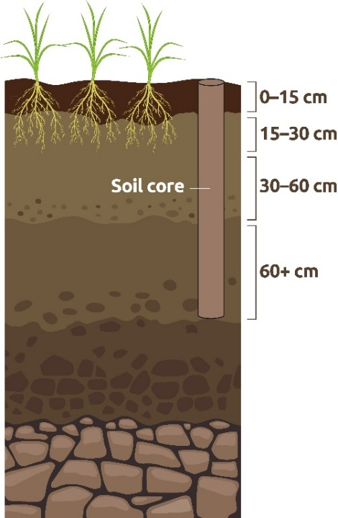
Figure 1 shows a cross section of soil from the surface to the parent rock. The sampling probe is shown inserted from the surface level to 100 cm deep. Separate samples are shown for the depths 0–15, 15–30, 30–60 and 60+ cm.

2.4.2 Soil sample analysis
Soil organic carbon stocks were assessed by measuring:
- SOC %
- Fine mass bulk density
- Sampling depth
SOC stock (tC/ha) = SOC % x fine mass bulk density (g/cm³) x depth (cm)

Table 1. Analysis methods for soil organic carbon and fine mass bulk density
Parameter | Analysis method
Soil organic carbon (SOC), % and t/ha | Elemental analysis by DUMAS
Mean fine dry bulk density, g/cm3 | Known volume of soil relative to its dry weight, <2 mm

The sampling methodology used will enable Equivalent Soil Mass (ESM) to be assessed in any subsequent sampling visits. This was considered important in terms of future-proofing the measurements to account for any changes in bulk density alongside SOC over time. ESM assesses SOC% (and other soil properties) on a normalised soil mass per unit area basis to account for differences in soil masses caused by changes to soil bulk density, often seen when land management is adjusted to improve soil organic matter.

2.5 Soil nutrients, pH and texture

2.5.1 Sample collection
Samples were taken around the SOC sampling points and combined to provide a representative composite sample per field. Sampling depth was 0–15 cm for consistency with UK surveys and to accommodate cropping changes over time.

2.5.2 Sample analysis

Table 2. Analysis methods for soil pH, texture and nutrients
Parameter | Analysis method
pH | 1:2.5 in water, potentiometric assessment
Texture classification and particle size distribution | Laser diffraction
Extractable P | Modified Morgans & Olsen
Extractable K | Ammonium nitrate extraction and ICP* spectrometry
Extractable Mg | Ammonium nitrate extraction and  ICP* spectrometry
Ca | Ammonium nitrate extraction and  ICP* spectrometry
*ICP = Inductively coupled plasma

2.5.3 Carbon audit tool
All farms in the project used the same carbon calculator to generate a cradle to farmgate carbon footprint. The tool was chosen based on its ability to report the following:
- Greenhouse gas emissions
- Reporting at whole-farm and product level
- Above- and below-ground carbon sequestration and losses
- GWP100 and GWP*
- Avoidance, reduction and removal of GHG emissions

Details relevant to the following elements were also reviewed:
- Alignment to ISO methodologies, where appropriate
- IPCC methodology to account for greenhouse gas emissions (using higher tier (2 or 3) where possible)
- Greenhouse Gas Protocol
- SBTi FLAG guidance
- Use of the Farm Levels Emissions API (FLEA)
- HESTIA data format
- Validation of entered data
The contract for this work was awarded to Agrecalc, which employs IPCC (2019) Tier 2 models for the majority of its greenhouse gas emissions reporting. In contrast, carbon stock changes were based on IPCC (2019) Tier 1 models, which rely on less accurate default data and, as such, have a higher degree of uncertainty associated with them.

2.6 Delivery of carbon audits and action planning on farm
Carbon audits are planned to take place on farm during years one, three and five. Following the carbon audits in years one and three, the consultant working with the farmer will discuss the outputs of the audit and compile an action plan in partnership with the farmer, aimed at reducing overall greenhouse gas emissions and improving the net carbon balance and environmental sustainability of that farm.
The action plan is tailored to the farm to reflect the farmer and their business, their business priorities, skills and resources. It records not only the actions the farmer wants to progress with but those they choose not to and why. The action plans will be reviewed in years three and five to check in with the farmers, discuss progress with the actions agreed, review the latest carbon audit and identify any new actions that may be relevant at that stage of the project.
Figure 2. Overview of delivery of carbon audits and action plans over the five-year pilot
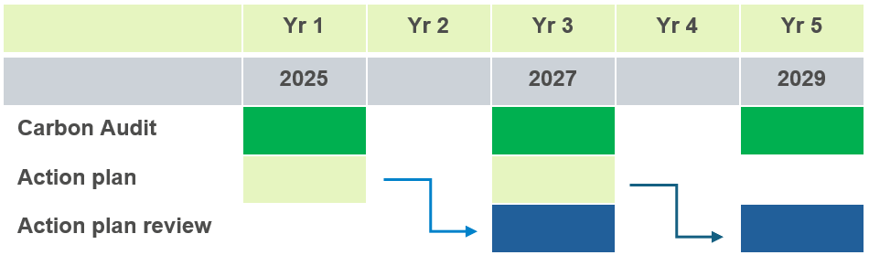

3. Conclusion
This report provides an overview of the methodology employed in year one. Being a pilot project, the methodology will be critically reviewed and potentially additional metrics added as the project progresses. The methodology followed was influenced by financial and time constraints and does not constitute a recommendation.
Further information and queries regarding this document should be sent to environment@ahdb.org.uk

4. References
Black, K., Lanigan, G., Ward, M., Kavanagh, I., O’hUallachain, D, O’Sullivan, L. (2023). Biomass carbon stocks and stock changes in managed hedgerows. Science of the Total Environment 871: 162073
Burrell, N.C., Jeffers, E.S., Macias-Fauria, M. and Willis K.J. (2024). The inadequacy of current carbon storage assessment methods for rewilding: A Knepp Estate case study. Ecological Solutions and Evidence 5(1), e12301. https//doi10.1002/2688-8319.12301
Forrester, D.I., Tachauer, I.H.H., Annighoefer, P., Barbeito, I., Pretzsch, H., Ruiz-Peinado, R., Stark, H., Vacchiano, G., Zlatanov, T., Chakraborty.T., Saha, S., Sileshi, G.W. (2017). Allometric equations for estimating tree biomass: A review. Forestry 90(5), 655–671.
IPCC, 2019. Refinement to the 2006 IPCC Guidelines for National Greenhouse Gas Inventories – Volume 4 Agriculture, Forestry and Other Land Use.
O’Sullivan, L, Lanigan, G., O’hUallachain, D., Rahini-Tanha, S & Black, K. (2024). Farm-Carbon: Hedgerows and Non-forest Woodland (Hedgerow carbon project). EPA Research project No 454 Environmental Protection Agency. ISBN 978-1-80009-158-0.
RUSLE (2015). https://esdac.jrc.ec.europa.eu/themes/rusle2015
Yu, X., Hyyppä, J., Holopainen, M., Vastaranta, M. (2010). Comparison of Area-Based and Individual Tree-Based Methods for Predicting Plot-Level Forest Attributes. Remote Sensing 2(6), 1481–1495. https://doi.org/10.3390/rs2061481

